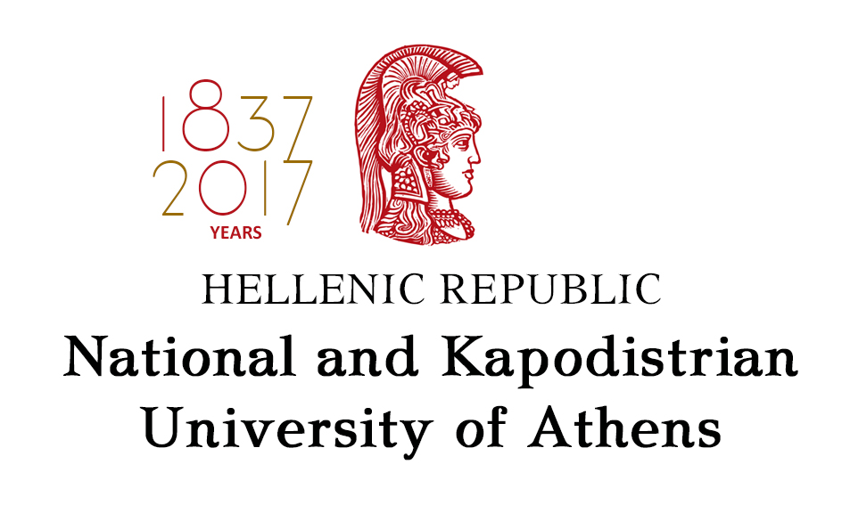
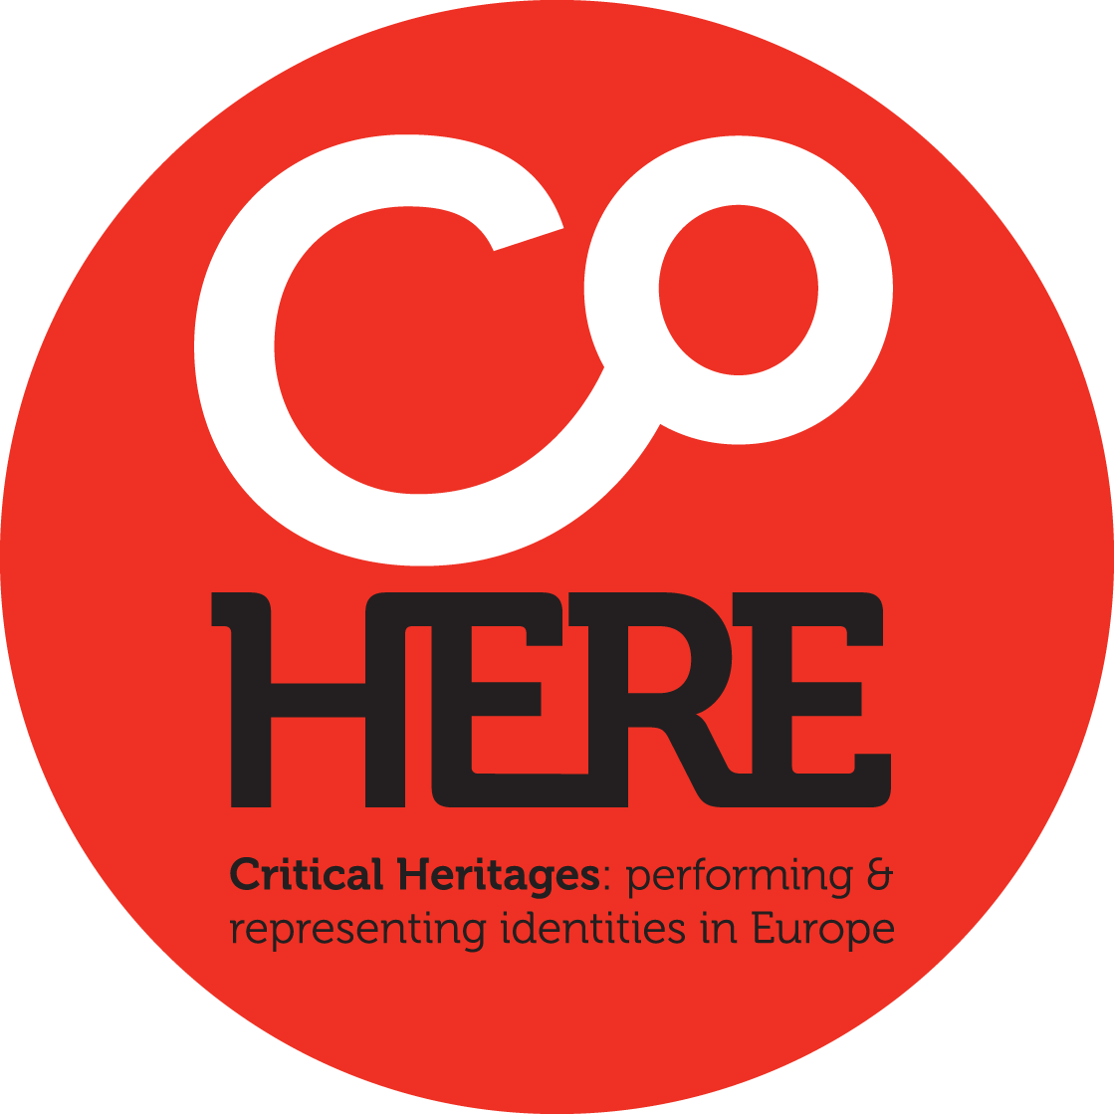



Critical Heritages: Performing and Presenting Identities in Europe

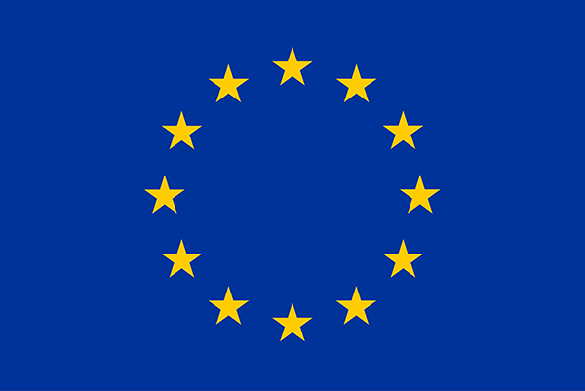
This project has received funding from the European Union’s Horizon 2020 research and innovation programme under grand agreement No 693289

GEOGRAPHY MATTERS:
European Identities in Curricula and Heritage

COHERE Workshop
National and Kapodistrian University of Athens
Department of Primary Education

March, 23 & 24 2017

Location:
March, 23 - Drakopoulos Hall, 30 Panepistimiou St., Athens
March, 24 – Marasleio Didaskaleio, 4 Marasli str. Athens

Scientific Committee:
Lia Galani
Evangelia Mavrikaki
Kostas Skordoulis
Krystalia Halkia

LEGAL NOTICE: The views expressed in this document are the sole responsibility of the author and do not necessarily reflect the views of the European Commission

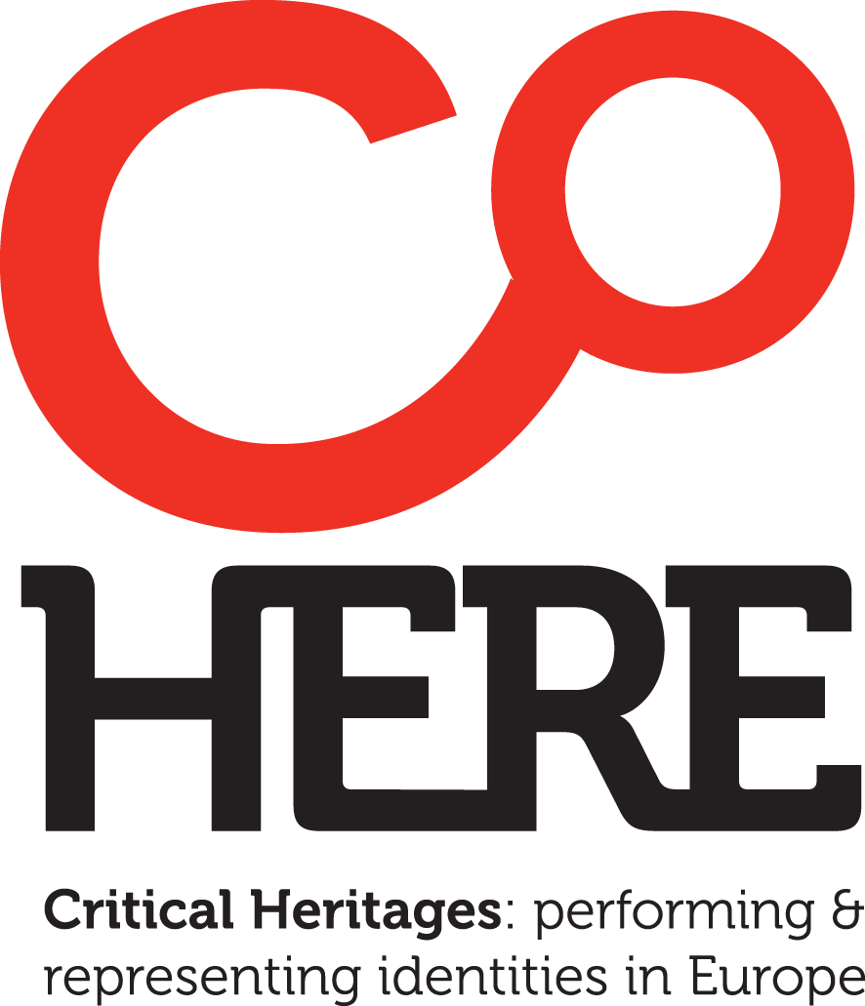

About CoHERE
Critical Heritages: performing and representing identities in Europe
CoHERE explores the ways in which identities in Europe are constructed through heritage representations and performances that connect to ideas of place, history, tradition and belonging. The research identifies existing heritage practices and discourses in Europe. It also identifies means to sustain and transmit European heritages that are likely to contribute to the evolution of inclusive, communitarian identities and counteract disaffection with, and division within, the EU. A number of modes of representation and performance are explored in the project, from cultural policy, museum display, heritage interpretation, school curricula and political discourse to music and dance performances, food and cuisine, rituals and protest. Across an experienced, multidisciplinary consortium we take various theoretical and methodological approaches to these. Relevance to the work programme is ensured through key approaches, which are: 1) the relational study of productions and experiences of heritage at institutional, social and personal levels, including research into people’s activities and attitudes; 2) research by practice and the provision of publicfacing dissemination activities; and 3) the critically-informed development of instruments (e.g. models for policy, curricula, museum and heritage practice) intended to promote reflection on and valorisation of European heritages and to engender socially-inclusive attitudes. The project is multidisciplinary, including museum, heritage and memory studies, cultural history, education, musicology, ethnology, political science, archaeology, ethnolinguistics and digital interaction design. The consortium comprises 12 partners over 9 countries, including universities, an SME, two museums and a cultural network. The research covers diverse European territories and realities comparatively and in depth.
COHERE on CORDIS Website: http://cordis.europa.eu/project/rcn/199996_en.html
COHERE web page: https://research.ncl.ac.uk/cohere/

https://www.facebook.com/cohere.eu/

https://twitter.com/cohere_eu

March 23, 2017
Location: Drakopoulos Hall, 30 Panepistimiou St., Athens

Abstracts

Session 1

Notions of Cultural Heritage in EU Policy Papers

Kostas Skordoulis
Professor
School of Education, National and Kapodistrian University of Athens, Greece

This paper studies and analyzes notions of Cultural Heritage as they appear in European Union policy documents.
The paper, in its first part, gives a chronological account starting with the appearance of the term in the Hague Convention (1954), the first international attempt to legally protect cultural property, till the 2014 Conference “Heritage First! Towards a Common Approach for Sustainable Europe” organized by the Hellenic Presidency of the European Council where cultural heritage is considered as a driving force for active engagement and social responsibility consisting a resource and prerequisite for a Europe of sustainable and inclusive growth.
In its second part, the paper traces the conceptual development of the term vis-à-vis the concept of identity, in the light of the Copenhagen Declaration of European Identity (1973) where “common heritage” is counter posed to the “diversity of cultures” with the perspective to strengthen the sense of a shared European Identity. Finally, the paper discusses, with a critical mind, the European Agenda for Culture where Heritage is considered as a sub-factor of culture, and falls within the scope of cultural policies incorporating the theoretical flaws of postmodernity.

Heuristic Uses of the Past: the Holocaust in museum education

Chris Whitehead
Professor
The Newcastle University Upon Tune, UK

This short paper will discuss the moral tradition of ‘learning the lessons’ of history as a means of constructing civil futures. Moral-heuristic reference to the past is at its most in ‘Never Again’ discourses, particularly around the Holocaust. However, there are critical problems associated with this. One is that the ‘caution’ in the tale – what it is that public actors warn against – can differ, such that the historical memory of the Holocaust has powered arguments both for and against the EU. The other problem arises from debates in Memory Studies that have problematized the real civil value of Holocaust memory, suggesting instead that it has become overdetermined, conventionalized and no longer sufficiently ‘difficult’ to have the presumed heuristic effects. Finally, there is little precise engagement in any scholarly literature about whether and how to instrumentalize the past for public benefit, largely because of suspicion of instrumentalism tout court. This is left to the heritage profession to do, and I make reference to specific education programmes (mainly in museums) that show how the Holocaust is used to educate schoolchildren.

Populism as a Political Style in Europe: Exploitation of Heritage and Nativism

Ayhan Kaya
Professor
Istanbul Bilgi University, Turkey and European University Institute, Florence

Populist political style has become very widespread together with the rise of neo-liberal forms of governmentality capitalizing on what is cultural, ethnic, religious and civilizational. The victory of Donald Trump, the success of UKIP in Brexit Referandum, the growing popularity of Geert Wilders, and the rise of Tayyip Erdoğan are all examples of populist rhetoric, which has become rooted in the European space as a phenomenon to stay. The common denominators of all these populist leaders is the way they exploit heritage, history, culture, nativism, national and/or religious identity, civilizational features and the past. The supremacy of ethno-cultural–religious discourse in these examples is likely to frame many of the social, political, and economic conflicts within the range of societies’ religious differences. Many of the ills faced by migrants and their descendants, such as poverty, exclusion, unemployment, illiteracy, lack of political participation, and unwillingness to integrate, are attributed to their Islamic background, believed stereotypically to clash with Western secular norms and values. Accordingly, this paper will argue that “nativism” and "Islamophobism" in the European forms of contemporary populism, and “Islamism” in the Turkish case are likely to be key ideological forms in which social and political contradictions of the neoliberal age are dealt with, and that this form of culturalisation is embedded in migration-related inequalities as well as geopolitical orders. This paper will claim that culturalization of political, social, and economic conflicts has become a popular sport in a way that reduces all sorts of structural problems to cultural and religious factors – a simple way of knowing what is going on in the World for the individuals appealed to the populist rhetoric.

Session 2

From Cartographic to Literary Imagination: the Figure of the Map in contemporary children’s literature

Tzina Kalogirou¹ & Konstantinos D. Malafantis²
^{1,2} Professors
School of Education, National and Kapodistrian University of Athens, Greece

This paper is an attempt to offer insights into how cartographic imagination is reflected on picturebooks for young audiences. Elaborating further a typology of maps employed by authors and illustrators( Tzina Kalogirou & Konstantinos Malafantis, “Literature as an Imaginative Map of the Universe: Travel and the Cartographic Imagination in Books for children”,forthcoming publication), we address the idea of travel in children’s literature. However, we are not particularly interested in all kinds of travels and itineraries; our primary interest is in those books that represent travels with particular literary associations. All the books we wish to put under discussion in this paper share the following common characteristics: To begin with, the notion of travel is central to the articulation of its narratives. The reader is engaged into a pure forward motion of a journey while being initiated into new and different to each other territories. Furthermore, the figure of the map is employed by illustrators to highlight issues of textual representation and to stimulate readers’ imagination. Last but not least, continents and countries of the world are represented in a highly subjective way. Geography corresponds not simply to specific locales but more importantly to human imagination, stimulating memories of several reading and artistic experiences. The narrative invokes the presence of writers, characters, and fictional works in landscapes and places.

The Role of Geography in Turkey’s Nation Brand: Deconstructing Inbetweenness and Hybridity in Brand Turkey

Dr. Ayşe Tecmen
Researcher
European Institute of Istanbul Bilgi University, Turkey

In 2010, as foreseen in Turkey’s European Union Communication Strategy (2010), the AK Party government initiated its nation branding efforts. As a part of foreign policy strategy; Brand Turkey has since become an integral instrument in Turkey's attempts for legitimacy as a strong regional and international actor. Branding efforts are carried out under the official brand slogan “Turkey: Discover the potential” (established in 2014), which builds on the country’s geographical proximity to Europe and the Middle East, as well as cultural and historical ties. While the “cradle of civilization” discourse, and the “bridge” metaphor, which are the cornerstones of Brand Turkey, have been established tropes of Turkey’s outward image projection processes, the national self-image projected by the Turkish state has favoured the nation’s European characteristics. The AK Party government’s deployment of Turkey’s cultural heritage assets, on the other hand, attempts to construct a non-antagonistic, and non-hierarchical relationship between Europe and the Middle East to subvert dominant geopolitical knowledge on Turkey. This is also aligned with the government’s attempts to brand Turkey as an indispensible asset in global politics through its cultural hybridity. Drawing on the intellectual capital of the nation’s heritage, history, culture and geography, Brand Turkey discursively constructs Turkey as both European and Middle Eastern which then comprises the country’s “potential”. This paper investigates the role of culture and heritage in Brand Turkey by deconstructing how the AK Party government constructs Turkey’s geographical belonging inbetween Europe and the Middle East.

Refugees in Greek picturebooks

Angela Yannicopoulou
Professor
School of Education, National and Kapodistrian University of Athens, Greece

Since Europe and Greece currently face a hard refugee crisis, new picturebooks about it are published. Picturebooks on refugees, though not many, can be divided into two distinct categories: those concerning the current crisis, where foreigners fled to Greece, and those that present refugees in the historical settings of 1922, when Greeks found protection in the country. It is obvious that since picturebooks about Greek refugees aim at preserving historical memory, they focus on the cultural heritage of the refugees and keep referring to the places they left. On the contrary, the books about current refugees, written in order to teach children to have compassion to them, prefer not to mention their different languages, religions, cultures or the places they abandoned.

Session 3

Cultural Heritage in European 'Borderlands': The Role and Perception of Classical Antiquity

Troels Myrup Kristensen
Associate Professor
Aarchus University, Denmark

This paper will outline ongoing research on the production and transmission of European heritage through the lens of Danish archaeological fieldwork in Bodrum, Turkey. Danish archaeologists have been active in Bodrum for more than fifty years, first in the excavations of the Mausoleum, one of the seven wonders of the ancient world, and later in a number of other areas of the ancient city. As part of CoHERE work package 5 ‘Education, Heritage and Identities’, we are planning to study the history and uses of Classical heritage in what can be defined as two European ‘borderlands’, Turkey and Denmark. The paper will thus look at the motivations for and experiences of undertaking Danish archaeological fieldwork in Turkey, and secondly, the perceptions of Classical Antiquity in the contemporary Turkish context.

International scientific vocabulary in Geography. Greek words and common Cultural Heritage

Evgenia Magoula¹ & Konstantina Ioannou²
¹ Associate Professor, ² PhD student
School of Education, National and Kapodistrian University of Athens, Greece

A large number of words of the scientific vocabulary has been created based on words or roots from classical languages, ancient Greek and Latin, and are common concepts in many different languages. These words form the International scientific vocabulary.
Geography, a science with roots reaching back in time in many countries, has its own scientific terminology, which is based mainly on Greek words and roots. The name of science goes back to ancient Greek geographer pioneers around 300 BC.
Basic concepts of geography with Greek roots are e.g. atlas, ocean, energy, meteorologist, aerial, ecosystem, agriculture, anemometer. The words from the Latin are e.g. vital, natural, model, lava.
In the present paper, we examine international words, with Greek origin, in geography over the concepts of culture and perceptions of the world, originating from antiquity with enduring value until today. The view presented in this paper is that these concepts could be utilized in the teaching approach of geography and natural sciences, so that students comprehend them more clearly. Common roots of our culture are highlighted.

Living classical heritage. The role of classics in high school teaching in Denmark

Vinnie Nørskov
Associate professor and museum director
Aarhus University, Denmark

The classical heritage is often considered essential in the definition of European culture in connection with Christianity and the Age of Enlightenment. In Denmark, here considered as an example of the Northern outskirts of Europe, this heritage developed into an integrated part of thoughts, aesthetics and visual culture of the country especially since the eighteenth century. This paper discusses two expressions of this heritage, firstly the introduction of the subject ‘oldtidskundskab’ (Classics or Altertumswissenschaft) as an obligatory subject in Danish high schools in 1903, secondly the role of classical architecture in the cityscape of Aarhus since the early nineteenth century. In 2008 the Museum of Ancient Art and Archaeology investigated the classical heritage in the present city providing an excellent case for high school teaching in the reception and role of the classical past today.

Session 4

Cultural practices of spatial organization and transnational cooperation: The art of dry stone walling as an element of Intangible Cultural Heritage (UNESCO 2003 Convention)

Stavroula-Villy Fotopoulou¹ & Rea Kakampoura²
¹Director of Modern Cultural Assets and Intangible Cultural Heritage,
Hellenic Ministry of Culture and Sports
²Assistant Professor
School of Education, National and Kapodistrian University of Athens, Greece

The Convention for the Safeguarding of Intangible Cultural Heritage has been adopted by UNESCO in 2003 and since then it has helped to bring about a significant increase in international debate about not only the nature and value of intangible heritage, but also the meaning and character of heritage more generally. More importantly, the implementation of the ICH Convention has contributed significantly not only to the re-examination of the dominant ideas about the role and meaning of heritage in contemporary societies, but also to the development of new management, conservation and/or preservation practices.
The anthropological approach to culture and the refocusing of social sciences on processes, have proved to be significant factors in the re-definition of heritage as an entity made up of various complex and interdependent expressions, revealed through social practices and customs. Today, it is the diversity of expressions that create the definition of heritage.
In this presentation we will examine one ICH element in the Greek National Inventory of ICH, that of Dry Stone Walling, following the steps that are recommended by the mechanism of the Convention, regarding its valorisation as ICH element and its further enhancement through educational programmes for school students, as well as the selection made by the Greek administration to nominate it as multinational file for a possible inscription on the Representative List of ICH of Humanity.

Planning the survey on Song and Dance Celebration in three Baltic states: main research questions (Latvia, Estonia, Lithuania)

Jānis Daugavietis
The Research Center of the Latvian Academy of Culture, Latvia

During the post-soviet years there have been several academic studies (including surveys) on Song and Dance Celebration in all three Baltic states. They covered two main themes: national identity and cultural participation. This is the first time when representative survey of population and participants of Song and Dance Celebration with common methodology is planned simultaneously in Latvia, Estonia and Lithuania. In order to produce comparable data, in CoHere survey we (Latvian Academy of Culture) are replicating some of the questions from the previous questionnaires, but also we'll add new question blocks, which are dealing directly with CoHere goals, like performance of national/ European identity through participation in the Celebration.
We assume, that so called 'Process of Celebration' (which usually is understood as never ending chain of 5 years cycles from one gala event to the other) is a institution and site of learning, performing and therefore reproducing certain identities. The Song and Dance Celebration in Baltic States is perceived as one of the main phenomena which has created the nations in the end of 19th century (especially Estonian and Latvian), and then led to the forming independent states in 1918. Since then, even during 50 years of Soviet occupation, Celebrations has been instrument which continually reproduces the national identity.
The 1st research question concerns the identity and heritage: is there place of an European identity in the Song and Dance Celebration? Are national identities, still championed by ideology of Celebration, corresponds to the current situation or just recreates imagined and ideal community of Latvian, Estonian, Lithuanian peasantry centuries ago? How inclusive these identities can be towards new realities and inclusion of other?
The 2nd research question asks if there are considerable differences in people's attitudes in three Baltic states. If there are deviations, it might show us ways in which Celebrations can change.
The 3rd research question presumes that there might be internal differences solely based on people’s place of residence. Previous research suggests, that involvement in the state supported amateur arts are more vivid in those municipalities which are not too close to the big cities / towns, so they must rely on their own cultural infrastructure (of course if they have it).
The 4th research question relates to the informal education: do people (participants and audience) learn something participating/ attending Celebrations and connected events? If yes, do these skills and knowledges help them to build their human, social, symbolic or other capitals?
The main place of Celebration week events (concerts, competitions, exhibitions) is capital Rīga. The collectives of singers, dancers and other traditional amateur arts, including some diaspora ensembles, gather from all the country. The participants forms virtually visible group in the city and the capital becomes even more central spatial focus of nation's attention. Outsiders ‘bring’ to the Rīga their regional identities (Latvian language dialects, regional variations of ethnic costumes), in return they receive experience in being in the big city. Once in five years imagined Latvian nation is again seen in one place: on the streets of capital and in gala concert. For the Baltic countries this model of capital-centric nationhood Celebration seems durable. Can this be replicated at the EU level? USSR have had some kind of soviet-united nations gatherings.

Different stakeholders in the Song and Dance Celebration (in three Baltic countries): research overview

Liga Vinogradova¹ & Agnese Treimane²
^{1,2} The Research Center of the Latvian Academy of Culture, Latvia

In the research programme “Sustainability of Latvian Cultural Traditions in an Innovative Environment/Habitus" implemented by the Research Centre at the Latvian Academy of Culture we have studied different primary stakeholders of the Song and Dance Celebration tradition - participants (from three Baltic countries and Nordic countries, in Latvia – also the youth separately), art group leaders, chief-conductors and chief-leaders and coordinators in local governments. Previously we have gained data also about collectives in Diaspora, and we also want to collect opinions of government representatives – both of the state and of municipalities. So far results show that not only the process of this tradition is different in three Baltic countries and in Nordic countries, but also stakeholders have different motivations for participating and different attitudes towards this tradition.

March 24, 2017

Project Meeting (Not open to public)
Location: Marasleio Didaskaleio,
(Institute for Primary Education Teachers)
4 Marasli str., Athens

9:30 – 10:00 WP5: Milestones - deliverables
10:00 - 11:00 Tonguc Ibrahim Sezen, Faculty of Communication, Department of Communication Design and Management (IBU), “Game design for social projects”.

11:00-11:30 Break

11:30 - 12:00 WP5 and Routledge editions: Tips of Inspiration – Content, Design
12:00 - 13:00 Dissemination – Next steps

13:00 – 14:00 Lunch

