ΣΥΛΛΟΓΟΣ ΔΙΔΑΚΤΙΚΟΥ ΕΡΕΥΝΗΤΙΚΟΥ ΠΡΟΣΩΠΙΚΟΥ
ΙΑΤΡΙΚΗΣ ΣΧΟΛΗΣ ΠΑΝΕΠΙΣΤΗΜΙΟΥ ΑΘΗΝΩΝ (Δ.Ε.Π.)

ΔΙΟΙΚΗΤΙΚΟ ΣΥΜΒΟΥΛΙΟ 2017-2019. Μέλη: Θ. Βασιλακόπουλος, Β. Γεννηματά, Ε. Ευσταθόπουλος, Χ. Κλωνάρης, Γ. Μαστοράκος, Γ. Σιάσος, Κ. Σπέγγος, Ν. Σύψας, Π. Χαλβατσιώτης,

8/3/2017
ANNOUNCEMENT
HONORARY DISTINCTIONS

As part of the effort of our Association to publicize the important distinctions of our members at national and international level, we have the pleasure to announce the following:

Our colleague, Associate Professor of Internal Medicine & Metabolic Diseases Mrs Erifili Hatziagelaki is Visiting Professor at the German Diabetes Center (DDZ), Leibniz Center for Diabetes Research at Heinrich Heine University-Düsseldorf Germany (Director: Prof. M. Roden) since November 2015. This collaboration has already yielded significant results through common research protocols and work.

Our colleague, Assistant Professor Mrs Maria Roumpelaki (Laboratory of Biology, Department of Medicine, School of Health Sciences), was honored by UK Alumni Awards 2017 in the category Professional Achievement Award (https://www.britishcouncil.gr/en/study-uk/alumni-awards). Greece is one of the few countries globally honoured to be hosting the Study UK Alumni Awards for the first time, in partnership with the British Embassy Athens, the British Graduates Society (BGS) and the British-Hellenic Chamber of Commerce.
The event was organized in Greece by the British Ambassador and British Council Director Greece.

These successes are the culmination of many years of continuous research and clinical work, and are a distinction for our School and our University.

The Board of Association | 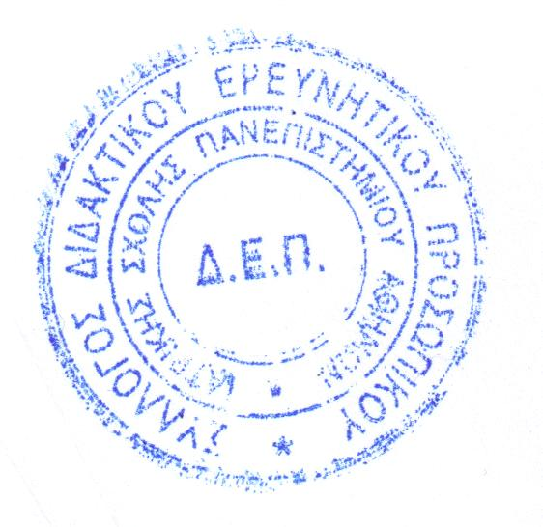

Σύλλογος Mελών ΔΕΠ Ιατρικής Σχολής, Μικράς Ασίας 75, 115 27, Γουδή, Τηλ.: 210-7462256, FAX: 210-7462256, Email: dep_med_uoa@yahoo.gr

